IDEAS TO TRY
for stimulating students’ imagination.

In vocational home economics, each student is to complete a six-hour home project (Individual Extended Experience) for each six weeks. The project counts as 1/6 of their six weeks’ grade.

This year, I am planning to incorporate a lesson on environmental issues and use recycling as a choice. I will introduce the unit with samples of recycled products - toys made from recycled items and clothing that has been reused.
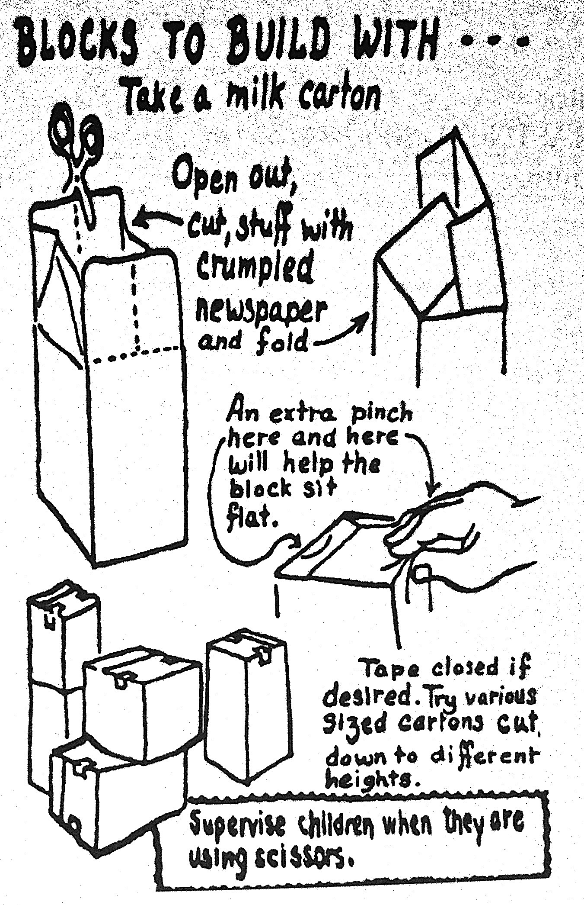
We will read aloud an article which discusses how teens can help the environment. Then brainstorming will be done in small groups to get other concrete suggestions on ways to save the environment.

The students will be assigned a notebook which will demonstrate ways to save the environment:

SAVE OUR ENVIRONMENT NOTEBOOK
Using old magazines, find 2 pictures which can show conservation or recycling of natural resources in the following areas:
- Electrical/natural gas
- Transportation food
- Waste/garbage water
Caption each picture to state how you can conserve or recycle.
Put the sheets in the above order.
Put this sheet on top to serve as a grade check off sheet. Staple notebook.
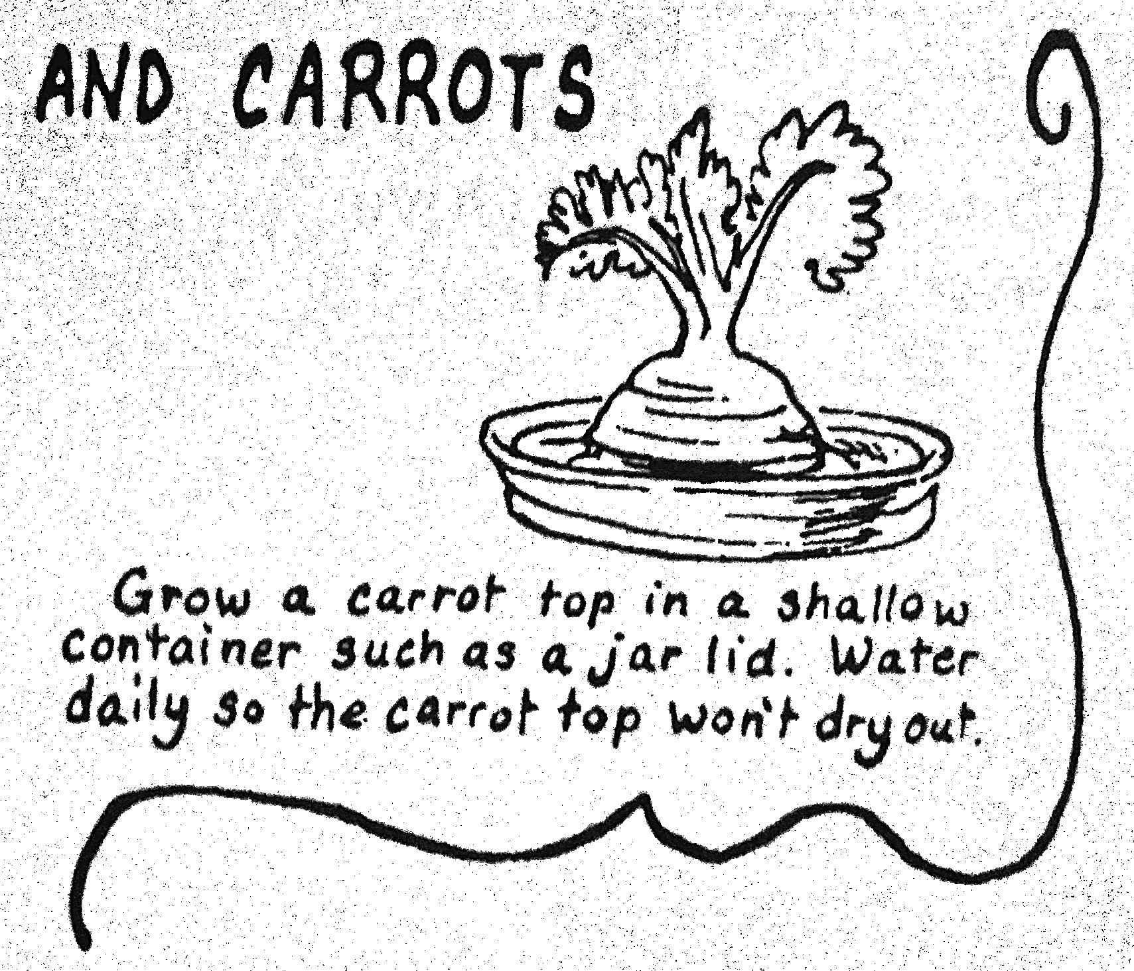

Submitted by an Akron City School Teacher

